**PROJECT BASED LAB REPORT**

**On**

**HOTEL MANAGEMENT SYSTEM**

**Submitted in partial fulfilment of the**

**Requirements for the award of the Degree of**

**Bachelor of Technology**

**In**

**ELECTRONICS AND COMMUNICATION ENGINEERING**

**By**

**ROHINI PANDIRI 2100031934**



**DEPARTMENT OF ELECTRONICS AND COMMUNICATION ENGINEERING**

**K L University**

Green Fields, Vaddeswaram, Guntur District-522 502

**2016-2017**

**K L University**

**DEPARTMENT OF ELECTRONICS AND COMMUNICATION ENGINEERING**



***CERTIFICATE***

This is to certify that this project based lab report entitled **“HOTEL MANAGEMENT SYSTEM”** is a bonafide work done by  **ROHINI PANDIRI 2100031934** in partial fulfilment of the requirements for the award of degree in **BACHELOR OF TECHNOLOGY** in **ELECTRONICS AND COMMUNICATION ENGINEERING**  during the Academic year 2021-2022.

**Faculty in Charge Head of the Department**

Smt.P.S.G.Aruna Sri Dr.V. Srikanth

**Project guide**

Dr.M.Jaya Bhaskar

**K L University**

**DEPARTMENT OF ELECTRONICS AND COMMUNICATION ENGINEERING**



***DECLARATION***

We hereby declare that this project based lab report titled **“HOTEL MANAGEMENT SYSTEM”** has been prepared by us in partial fulfilment of the requirements for the award of degree “**BACHELOR OF TECHNOLOGY in ELECTRONICS AND COMMUNICATION ENGNEERING**” during the Academic year 2016-2017.

We also declare that this project based lab report is of our own efforts and it has not been submitted to any other university for the award of any degree.

**ROHINI PANDIRI 2100031934**

**ACKNOWLEDGEMENT**

Our sincere thanks to **Dr.M.Jaya Bhaskar** in the Lab for their outstanding support through out the project for the successful completion of the work.

We express our gratitude to **DR.V. SRIKANTH,** Head of the Department for Computer science and Engineering for providing us with adequate facilities, ways and means by which we are able to complete this project based Lab.

We would like to place on record the deep sense of gratitude to the honourable Vice Chancellor, K L University for providing the necessary facilities to carry the project based Lab.

Last, but not the least, we thank all Teaching and Non-Teaching Staff of our department and especially my classmates and my friends for their support in the completion of our project based Lab.

**ROHINI PANDIRI 2100031934**

**CONTENTS**

|  |  |
| --- | --- |
| **s.no** | **Contents** |
| **1.** | **ABSTRACT** |
| **2.** | **INTRODUCTION** |
| **3.** | **FUNCTIONAL REQUIREMENTS** |
| **4.** | **NONFUNCTIONALREQUIREMENTS** |
| **5.** | **CODE** |
| **6.** | **OUTPUT** |

**ABSTRACT** :

The theme of my Project is Hotel Management System. This Project is a fine thought to make the complex procedure of the Hotel management system to an easy manner which is systematic, modular designed, selective menu based user display.  The modular design and constructed system is very much user oriented in which user can easily understand the tools and can do edit of his own choice. The system is not any tough more and does not possesses many applications but it is made by focusing on the maintaining records employee’s actions in a computerized system rather than time taking and cumbersome manual system. The Purpose of the whole process is to ease the daily or regular activities of the Hotel Management into an automatic computerized retrievable process. The daily activities includes the Room activities, Entering details of the new customer check in, To allocate a room as per the customer need and interest, Recording the checkout time and details, Releasing or Empty of room and to record the process in a computer system for future.

The application of the Hotel Management System bears the following functions to use by the Administrator.

* Room status
* Details for the Customer Check in and Check out
* Allocation of Room as per the Customer Interest
* Statement of client Details
* Total Customers Present In The Hotel
* Total figure of clients in the lodge
* Total pay including advance

**INTRODUCTION:**

The project is done based on java programing. This is through object oriented programing. This gives some necessary information about hotels in cities . Main aim of this project is to implement an application which deals with maintaining of Hotel management activities. Every Hotel provides services to the customers who include accommodation

Billing of the services provided to the customers is the most important requirement that must be met by Hotel Management systems. The billing process must consider all the taxes, duties etc. that must be levied according to the directions of the Government from time to time.

The hotel management system must maintain the customer information, employee information, administrative information etc. The hotel management system must reduce manual work for maintaining records in files. The relevant data has to be collected and maintained in a database which holds historical data for a period of at least 6 months

**DESCRIPTION:**  
**1. Management of room information**

This module is about management of room information in this module we create room information for particular person using files and if they joins we will update room information for that particular person. We see whether the rooms are available or not. If rooms are available we will assign the room for particular person. Based up on that reports will be generated.

**2. Management of Customer information**

This module is about management of customer information in this module we create customer information for particular person using files and we update the customer information for that particular person. After assigning details we search the room for that person. Based on that we reports will be generated.

**3. Check-in and Check-out :**

This module is about check-in and check-out in this module we see that when the customer check in and check-out date of the customer according to that we update bill and generate reports.

**4. Integration :**

This module is about integration in this module we display the system manner and we process the menu and integrate all the modules and provide the security.

**FUNCTIONAL REQUIREMENTS**

**Purpose**  
The purpose of doing this project is to provide all the requirements for the Hotel Management System. The user can search easily anything regarding the hotels he want with moving here and there .This will make his time manageable and there will no waste of time in goingout.

|  |  |  |  |
| --- | --- | --- | --- |
| 1 |  | Hotel information |  |
|  |  | To search for the Hotel the user need | Here we will be creating the list of details of Hotel showing Name of hotel, address of hotel, identity etc. |
|  |  | Displays all facility details that hotel provided | This is used maintain the details of the hotels and the hotel details for the use |
|  |  | To search facilities in the hotel | This is used to search a hotel details when user gives a particular search number of that hotels name. |
|  |  | To generate details | Here in generating reports we will be able to display all the details of records of hotels with details in the form of files. |
| 2 |  | Main Module |  |
|  |  | To display System | After all modules were integrated through files we display the complete information. |
|  |  | To process menu | Here **Processing Menu** can be done through if else statements with all the modules that is present in the file. |
|  |  | Initializations | Here **Initializations** can be done to methods, variables as well as objects which are present in classes |
|  |  | To access | To provide easy access **we** informed everything to user which will able to access his details. We can be able to read the file and record of that file, and write that file where he can be able to do modifications for files that are present. |

**NON-FUNCTIONAL REQUIREMENTS**

ABSTRACT CLASS:

A class that is declared with abstract keyword, is known as abstract class in java. It can have abstract and non-abstract methods (method with body).**Abstraction** is a process of hiding the implementation details and showing only functionality to the user. Another way, it shows only important things to the user and hides the internal details for example sending sms, you just type the text and send the message. You don't know the internal processing about the message delivery.

ABSTRACT METHOD:

An abstract method is a method that is declared, but contains no implementation. Abstract classes may not be instantiated, and require subclasses to provide implementations for the abstract methods. Let's look at an example of an **abstract** class, and an abstract method.

SWITCH CASE:

In computer programming languages, a switch statement is a type of selection control mechanism used to allow the value of a variable or expression to change the control flow of program execution via a multiway branch.

FILES:

A Java class file is a file (with the .class filename extension) containing Javabytecode that can be executed on the Java Virtual Machine (JVM). A Java class file is produced by a Java compiler from Java programming language source files(.java files) containing Java classes.

EXCEPTION HANDLING:

An exception (or exceptional event) is a problem that arises during the execution of a program. When an Exception occurs the normal flow of the program is disrupted and the program/Application terminates abnormally, which is not recommended, therefore, these exceptions are to be handled.

**CODE:**

import java.util.*;

import java.io.*;

class Room

{

public void ac()throws IOException

{

Scanner s=new Scanner(System.in);

System.out.println("ac room cost per day is 1000");

String name;

int d,t,m;

System.out.println("enter how many days u want stay");

d=s.nextInt();

System.out.println("enter how many members");

m=s.nextInt();

System.out.println("enter ur name");

name=s.next();

t=1000*d;

System.out.println("your total bill is"+t);

File fil=new File("ac.txt");

if(!fil.exists())

{

fil.createNewFile();

}

BufferedWriter bw=new BufferedWriter(new FileWriter("ac.txt",true));

bw.write("number of days he/she want to stay"+d);

bw.newLine();

bw.write("number of members"+m);

bw.newLine();

bw.write("total bill"+t);

bw.newLine();

bw.write("name"+name);

bw.write("\n");

bw.newLine();

bw.close();

}

public void nac()throws IOException

{

Scanner s=new Scanner(System.in);

System.out.println("NON-ac room cost per day is 700");

int d,t,m;

String name;

System.out.println("enter how many days u want stay");

d=s.nextInt();

System.out.println("enter how many members");

m=s.nextInt();

System.out.println("enter ur name");

name=s.next();

t=700*d;

System.out.println("your total bill is"+t);

File fil=new File("nac.txt");

if(!fil.exists())

{

fil.createNewFile();

}

BufferedWriter bw=new BufferedWriter(new FileWriter("nac.txt",true));

bw.write("number of days he/she want to stay"+d);

bw.newLine();

bw.write("number of members"+m);

bw.newLine();

bw.write("total bill"+t);

bw.newLine();

bw.write("name"+name);

bw.newLine();

bw.write("\n");

bw.newLine();

bw.close();

}

public void acd()throws IOException

{

Scanner s=new Scanner(System.in);

System.out.println("ac-deluxe room cost per day is 1500");

int d,t,m;

String name;

System.out.println("enter how many days u want stay");

d=s.nextInt();

System.out.println("enter how many members");

m=s.nextInt();

System.out.println("enter ur name");

name=s.next();

t=1500*d;

System.out.println("your total bill is"+t);

File fil=new File("acd.txt");

if(!fil.exists())

{

fil.createNewFile();

}

BufferedWriter bw=new BufferedWriter(new FileWriter("acd.txt",true));

bw.write("number of days he/she want to stay"+d);

bw.newLine();

bw.write("number of members"+m);

bw.newLine();

bw.write("total bill"+t);

bw.newLine();

bw.write("name"+name);

bw.newLine();

bw.write("\n");

bw.newLine();

bw.close();

}

public void nacd()throws IOException

{

Scanner s=new Scanner(System.in);

System.out.println("non-ac deluxe room cost per day is 900");

int d,t,m;

String name;

System.out.println("enter how many days u want stay");

d=s.nextInt();

System.out.println("enter how many members");

m=s.nextInt();

System.out.println("enter ur name");

name=s.next();

t=900*d;

System.out.println("your total bill is"+t);

File fil=new File("nacd.txt");

if(!fil.exists())

{

fil.createNewFile();

}

BufferedWriter bw=new BufferedWriter(new FileWriter("nacd.txt",true));

bw.write("number of days he/she want to stay"+d);

bw.newLine();

bw.write("number of members"+m);

bw.newLine();

bw.write("total bill"+t);

bw.newLine();

bw.write("name"+name);

bw.write("\n");

bw.newLine();

bw.close();

}

public void disp()

{

Scanner s=new Scanner(System.in);

System.out.println("1.ac");

System.out.println("2.nac");

System.out.println("3.acd");

System.out.println("4.nacd");

}

}

class H

{

public static void main(String args[])

{

int i;

System.out.println("welcome to KLU Hotel");

System.out.println("the rooms types which are available in our hotel are:");

Room r=new Room();

r.disp();

Scanner s=new Scanner(System.in);

System.out.println("enter ur choice");

i=s.nextInt();

switch(i)

{

case 1:

try

{

r.ac();

}

catch(Exception e)

{

System.out.println("error");

}

break;

case 2:

try

{

r.nac();

}

catch(Exception e)

{

System.out.println("error");

}

break;

case 3:

try

{

r.acd();

}

catch(Exception e)

{

System.out.println("error");

}

break;

case 4:

try

{

r.nacd();

}

catch(Exception e)

{

System.out.println("error");

}

break;

}

}

}

**OUTPUT:**

**SCREEN SHOTS:**

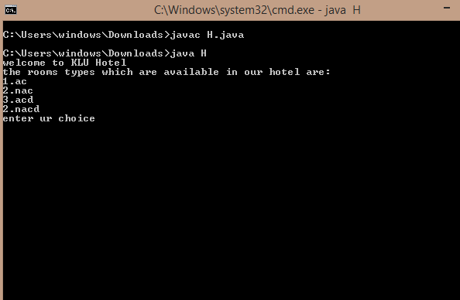

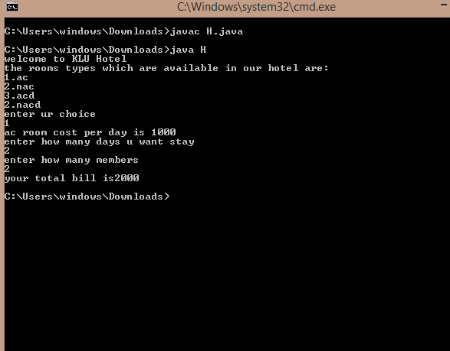

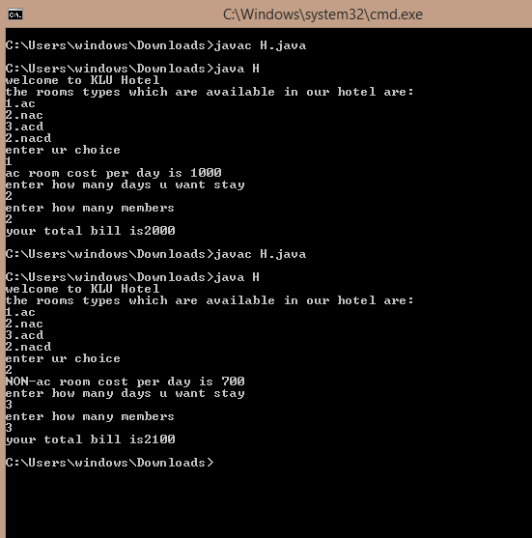

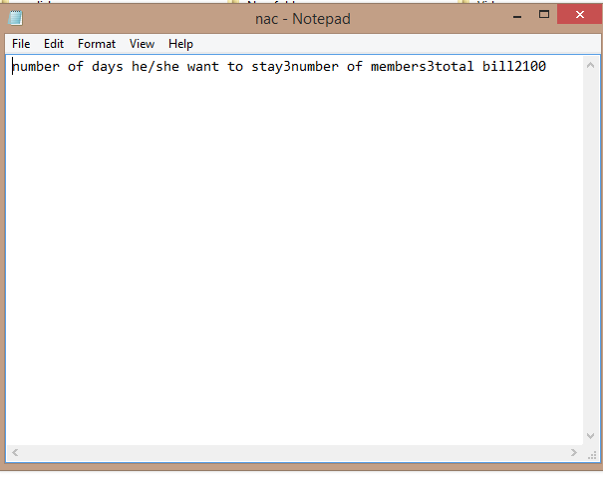

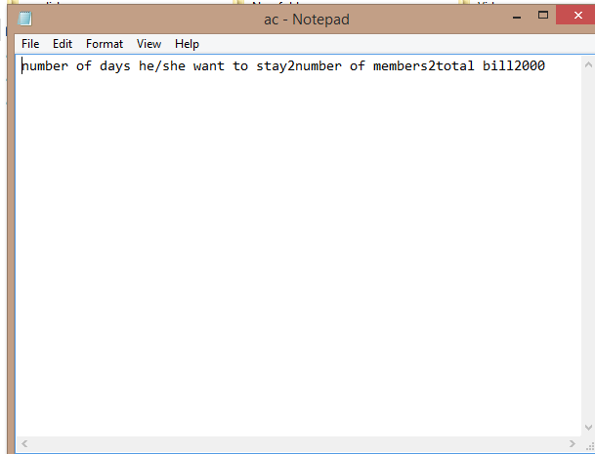

**Conclusion:**

By this project we can select the hotels easily and we can know the facilities available in the hotel easily.